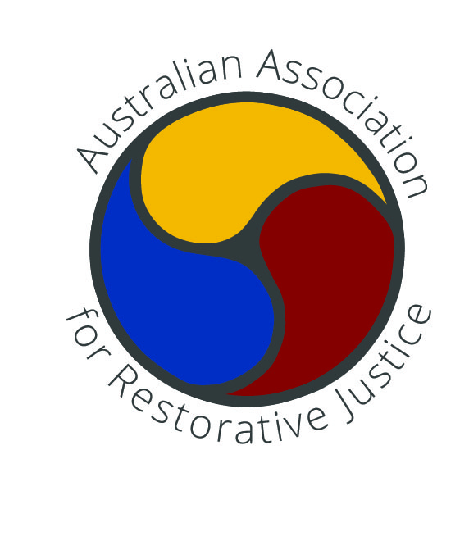

Application for Accreditation

as a Group Conference Convenor by the

Australian Association for Restorative Justice
The Australian Association for Restorative Justice (AARJ) has developed a system of accreditation for Group Conference Convenors. This system supports good professional practice among convenors, consistent with our Restorative Justice Best Practice Standards. It is a system of peer mentoring, supported by (i) specific guidelines on the content of key collegial conversations & (ii) external assessment of the written record of those conversations, with feedback from a senior convenor.

The guidelines guard against excessive “practice drift”, but still allow for flexibility of practice, and for creativity. External assessment provides the AARJ Accreditation Committee with an overview of the current range and quality of group conference convening, and provides convenors with tailored feedback.

What are the benefits of Accreditation for individual convenors?
Accreditation is a formal acknowledgement that a group conference convenor has attained a certain standard of professional practice. As part of the assessment process, a member of the AARJ Accreditation Committee will provide each convenor with feedback, suggestions and possibly professional connections to a broader network of colleagues, who can support ongoing skills development.
Accreditation provides formal recognition of skills, and makes those skills more portable from one program to another. Accredited convenors may choose to be listed in a directory on the AARJ website.

What do I need to provide to AARJ?
- Evidence of having completed appropriate Group Conference convenor training;
- A completed Application Form, including:
- contact details for two referees; &
- a written summary of each of four structured conversations (using Feedback Templates 1-3);
- Payment.

What will AARJ provide me?
The AARJ Accreditation Sub-Committee will:
- assess the documentation and provide a written response;
- conduct a structured discussion (by phone/video, or face to face) with the applicant, & provide feedback.
(The basic structure for this discussion is provided by Feedback Templates 3.)
The Committee will aim to complete these assessment tasks as soon as possible after receiving the completed application, ideally within 6 weeks (or 30 workings days).

Application Form
Name: ____________________________________________________________________________
Email: ____________________________________________________________________________
Mobile Phone(s): ___________________________________________________________________
Postal Address: ____________________________________________________________________
Organisation/Business: ______________________________________________________________
Job Title: _________________________________________________________________________
AARJ member? YES
Please provide the following information:
- I have successfully completed a training course in Group Conferencing, and that course meets the standards described in the AARJ Best Practice Standards (Section 1, A1)

YES NO
Title of course: ________________________________________________________________________
Name(s) of presenter(s): _________________________________________________________________
(Please attach evidence of successful completion, including a copy of the course certificate if available).
- I have the requisite knowledge and skills base as described in the AARJ Best Practice Standards
(Section 1, A2-A3).
Please provide a basic description of your experience as a Group Conferencing convenor:
(If the space below is insufficient, feel free to attach an additional page).
________________________________________________________________________________________________________________________________________________________________________________________________________________________________________________________________________
- I have recorded written summaries of conversations using the structure of the Feedback Templates:

- After observing a group conference run by an experienced colleague;
(Use Template 1) TECHNIQUE-FOCUSED DISCUSSION TEMPLATE.

- After being observed by an experienced convenor facilitating a group conference;
(Use Template 1) TECHNIQUE-FOCUSED DISCUSSION TEMPLATE.
- After being observed by an experienced convenor facilitating a group conference, after having (i) previously convened at least six group conferences, or (ii) achieved one year of practice in convening group conferencing – whichever comes first;
(Use Template 2) STRATEGY-FOCUSED TEMPLATE

- After having had a conversation with my line manager after one year of practice.
(Use Template 3) REFLECTIVE PRACTICE TEMPLATE
Note: for independent consultants, this reflective practice conversation can be held with a member of the VARJ Assessment committee, as part of the assessment process.
- The following two referees have agreed to support my application.

They have agreed to be contacted by phone or email.
Referee 1
Name:
Organisation:
Job Title:
Email:
Phone:

Referee 2
Name:
Organisation:
Job Title:
Email:
Phone:

CHECKLIST
I have:
- completed appropriate Group Conference convenor training;
- nominated two Referees;
- included with this application a written summary of each of four structured conversations
(Templates 1-3);
- completed the application form;
- completed payment.

The cost to apply for accreditation is: $250 for VARJ members.

Please make your payment by EFT to AARJ:

  - BSB: 063 009
  - Account #: 1038 6269
Please provide, as EFT payment details: <your surname> & the abbreviation “ACCRD”.
Declaration: I declare that the information provided in this application is, to the best of my knowledge and understanding, true and correct
Signature:
_________________________________________________________________________________
Date: ____________________________________________________________________________
Email completed application form to: contact@aarj.org.au

