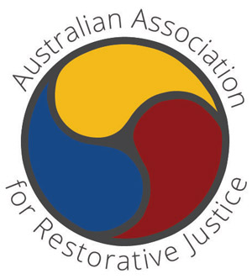

AGM AGENDA

AUSTRALIAN ASSOCIATION FOR RESTORATIVE JUSTICE

AGM COMMITTEE MEETING

Date: Wednesday, 9th December 2020
Time: 5:45 pm – 7:00 pm
Venue: Zoom

Committee members: David Moore, Michael Mitchell, Alikki Vernon, David Vinegrad, Daniel Clements, Angela Ballard, Glen McClure, Kate Taylor, Gen Higgins, Sam Nolan, Tom Bell, Aunty Lois Peeler.

Agenda item |  | Actions
Welcome
Apologies
Confirmation of minute taker
Confirmation of previous AGM minutes.
Business Arising from Minutes

- President’s Annual Report
- Treasurer’s Annual Report

Election of
- Office Bearers: President; Vice-President; Secretary; Treasurer;
- Committee members State & Territory representation & key areas of Professional Practice

- AARJ Updates & Plans for AARJ 2021

Presentation: Amanda Lutz, Director, Restorative Justice Unit, Canberra
ACT RJU: Achievements, Lessons, and Next Steps
We are encouraging a Christmas toast ‘on-line’ to replace our annual Christmas dinner. So, please join us with some celebratory beverage.

